Exp no: 5 Keerthika.K
241901046

Develop a Simple Calculator using XML-RPC .

AIM:
To develop a simple calculator application using XML-RPC (Extensible Markup Language Remote Procedure Call) for performing basic arithmetic operations between a client and a server.

INTRODUCTION:
XML-RPC is a remote procedure call protocol that uses XML to encode its calls and HTTP as a transport mechanism.
It allows a client program to execute functions on a remote server over a network.
In this experiment, we create a calculator service using XML-RPC in Python, where:
- The server defines arithmetic functions like addition, subtraction, multiplication, and division.
- The client sends requests to the server to perform these operations and receives the results.
This approach demonstrates distributed computing, where tasks are executed remotely using standard web communication.

ALGORITHM (Server Side):
- Start the program.
- Import the xmlrpc.server module.
- Create a server instance using SimpleXMLRPCServer((host, port)).
- Define functions for arithmetic operations such as:
  - add(a, b)
  - sub(a, b)
  - mul(a, b)
  - div(a, b)
- Register these functions with the XML-RPC server using server.register_function().
- Run the server continuously using server.serve_forever().
- Stop the program when communication ends.

ALGORITHM (Client Side):
- Start the program.
- Import the xmlrpc.client module.
- Connect to the server using ServerProxy("http://<server_ip>:<port>/").
- Call the remote functions such as server.add(a, b) or server.sub(a, b) through the proxy.
- Display the results returned by the server.
- Repeat as needed for other operations.
- Close the connection and stop the program.

Code(server):

Server.py
from xmlrpc.server import SimpleXMLRPCServer
def add(a,b): return a+b
def sub(a,b): return a-b
def mul(a,b): return a*b
def div(a,b): return a/b
def mod(a,b): return a%b
server = SimpleXMLRPCServer(("localhost", 8000))
print("Listening on port 8000 ... ")
server.register_function(add, "add")
server.register_function(sub, "sub")
server.register_function(mul, "mul")
server.register_function(div, "div")
server.register_function(mod, "mod")
server.serve_forever()

Code(client):
Client.py
import xmlrpc.client
proxy= xmlrpc.client.ServerProxy('http://localhost:8000/')
for i in range(5):
a=int(input("Enter a number:"))
b=int(input("Enter b number:"))
print("addition of given number is %d "%((proxy.add(a,b))))
print("sub of given number is %d "%((proxy.sub(a,b))))
print("mul of given number is %d "%((proxy.mul(a,b))))
print("div of given number is %d "%((proxy.div(a,b))))
print("mod of given number is %d "%((proxy.mod(a,b))))

Server(status):

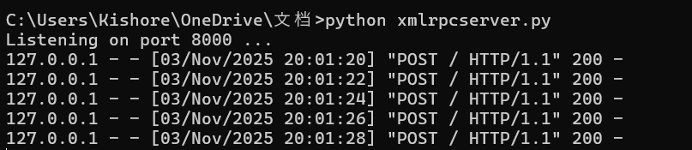

Client(status): 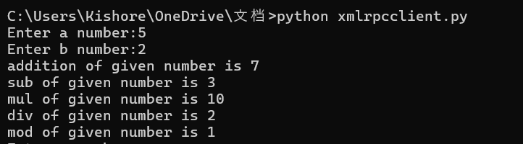

RESULT:
The XML-RPC-based calculator application was successfully developed and executed.
The client was able to perform arithmetic operations remotely by calling functions on the server, demonstrating the working of XML-RPC communication.

